**DẠNG 2 NĂM VÀ NHIỀU ĐỐI TƯỢNG**

The bar chart shows the percentages of students who found employment within 6 months of graduation over seven subject areas in 1995 and 2005 in Molovia.

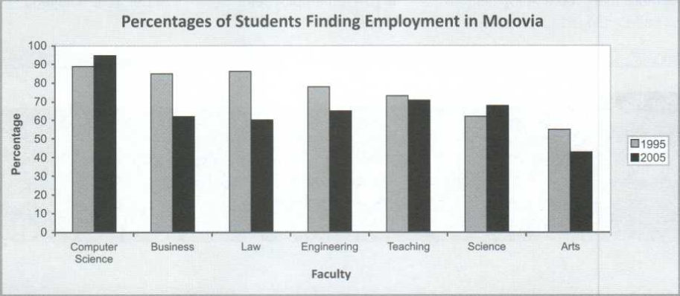

The bar chart illustrates data on the percentages of students who got a job within 6 months of graduation over seven suject areas in 1995 and 2005 in Molovia.

Overall, students got a job within 6 months of graduation over seven subject areas from 1995 to 2005 in Molovia was fell down and most students of computer science faculty got a job while half of arts students didn’t.

It is clear that, the percentages of computer science and science faculty both increased by 5%, from 90% in 1995 to 95% in 2005 with computer science faculty and from 60% in 1995 to 65% in 2005 with science faculty. Otherwise, business, law, engineering, teaching and arts was fell down by 2%-25%. So, students from computer science and science had more success in 2005 than 1995

As can be seen from the chart, in 1995, nearly 90% of computer science students found a job after graduation. Next, the rate of business, law and engineering was 85%, 86% and 80%. However, the opposite tendency could be seen in figures for arts faculty, which was only 55% students who found employment within 6 months of graduation. In 2005, the rate of computer science was increased to 95% and it was also the highest rate. Following computer science were teaching, science and engneering with 70%,69% and 65%. Meanwhile, the lowest rate, owned by arts faculty was 45%. So, graduates of computer science had the most success in finding jobs.

Arrcoding to the chart, we can see that the world had changed, more modern, more technology but there were fewer jobs available for students in most areas. Computer science always need more and more employees while others do not. That’s why most students of computer science got a job after graduation while most students of business, law, engineering, teaching and arts couldn’t got a job and they would be unemployed.

**DẠNG NHIỀU ĐỐI TƯỢNG VÀ NHIỀU TIÊU CHÍ**

**Task:** The chart below shows shares of expenditures for five major countries in the United States, Canada, the United Kingdom, and Japan in the year 2009.

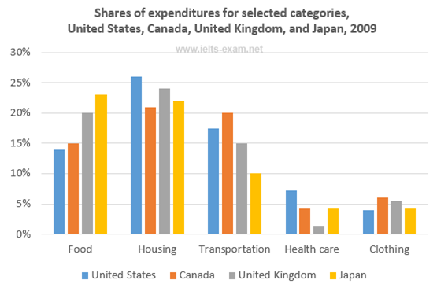

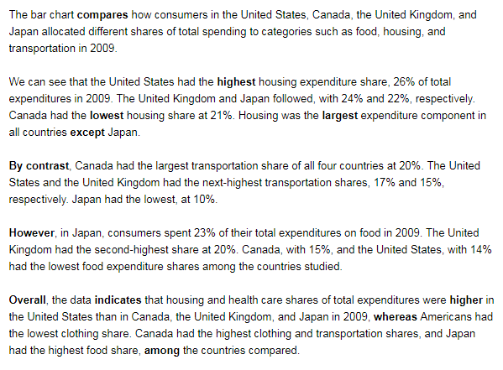

**PRACTICE 1**





**1. Luyện viết mở bài**

**New Introduction**

**…………………………………………………………………………………………………………………………………………………………………………………………………………**

**……………………………………………………………………………………………………**

**2. Luyện viết Overview**

**………………………………………………………………………………………………………………………………………………………………………………………………………………………………………………………………………………………………………………………………………………………………………………………………………………………………………………………………………………………………………………………….**

**3. Luyện viết thân bài**

**Đoạn 1**

**…………………………………………………………………………………………………………………………………………………………………………………………………………………………………………………………………………………………………………………………………………………………………………………………………………………………………………………………………………………………………………………………………………………………………………………………………………………………………………….………………………………………………………………………………………**

**Đoạn 2**

**…………………………………………………………………………………………………………………………………………………………………………………………………………….………………………………………………………………………………………………………………..…………………………………………………………………………………..…………………………………………………………………………………………………………………………………………………………………………………………………………………………………………….……………………………………………………………………**

**Đoạn 3**

**………………………………………………………………………………………………………………………………………………………………………………………………………………………..…………………………………………………………………………………..………………………………………………………………………………………………………………………………………………………………………………………………………………………………………………………………………………………………………………………………………………………………………………………………………………………**

**PRACTICE 2**



**Bài viết hoàn chỉnh**

**………………………………………………………………………………………………………………………………………………………………………………………………………………………..…………………………………………………………………………………..………………………………………………………………………………………………………………………………………………………………………………………………………………………………………………………………………………………………………………………………………………………………………………………………………………………**

**………………………………………………………………………………………………………………………………………………………………………………………………………………………..…………………………………………………………………………………..………………………………………………………………………………………………………………………………………………………………………………………………………………………………………………………………………………………………………………………………………………………………………………………………………………………**

**………………………………………………………………………………………………………………………………………………………………………………………………………………………..…………………………………………………………………………………..…**